SET 15 – PRODUCT SALES ANALYSIS
Aim
To analyze product sales for the first quarter using grouped bar chart, stacked area chart, and table in R.
Algorithm
- Create the product sales dataset.
- Convert monthly sales data into long format.
- Create a grouped bar chart for January, February, and March.
- Create a stacked area chart to show the overall sales trend.
- Display the monthly sales data in a table.
R Program
library(ggplot2)
library(tidyr)

sales <- data.frame(
Product=c("Product A","Product B","Product C"),
January=c(2000,1500,1200),
February=c(2200,1800,1400),
March=c(2400,1600,1100)
)

long <- pivot_longer(sales, -Product,
names_to="Month", values_to="Sales")

ggplot(long, aes(Month, Sales, fill=Product)) +
geom_bar(stat="identity", position="dodge") +
labs(title="Product Sales - First Quarter",
x="Month", y="Sales")

ggplot(long, aes(Month, Sales, fill=Product, group=Product)) +
geom_area(position="stack") +
labs(title="Overall Sales Trend",
x="Month", y="Sales")

print(sales)
OUTPUT:
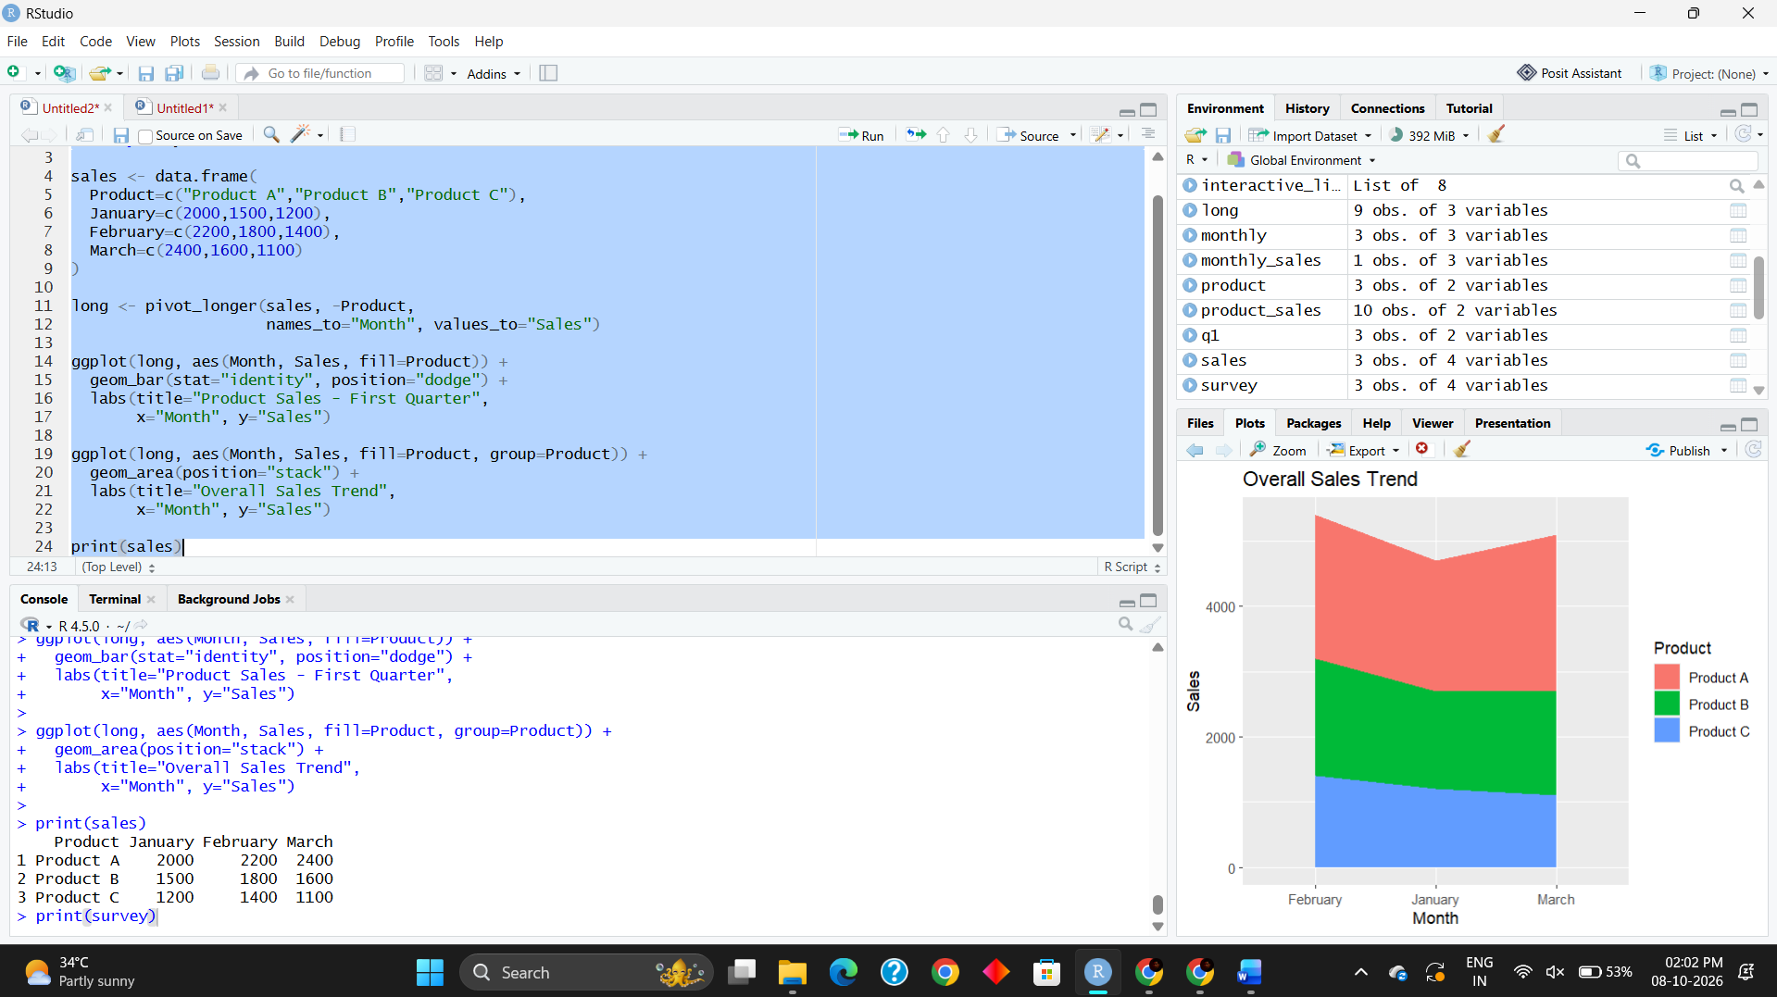
Result
The grouped bar chart successfully compares the sales of each product for the first quarter. The stacked area chart represents the overall sales trend, and the table displays the monthly sales data for all products.

